GSC: <http://gensc.org/> @genomestandards



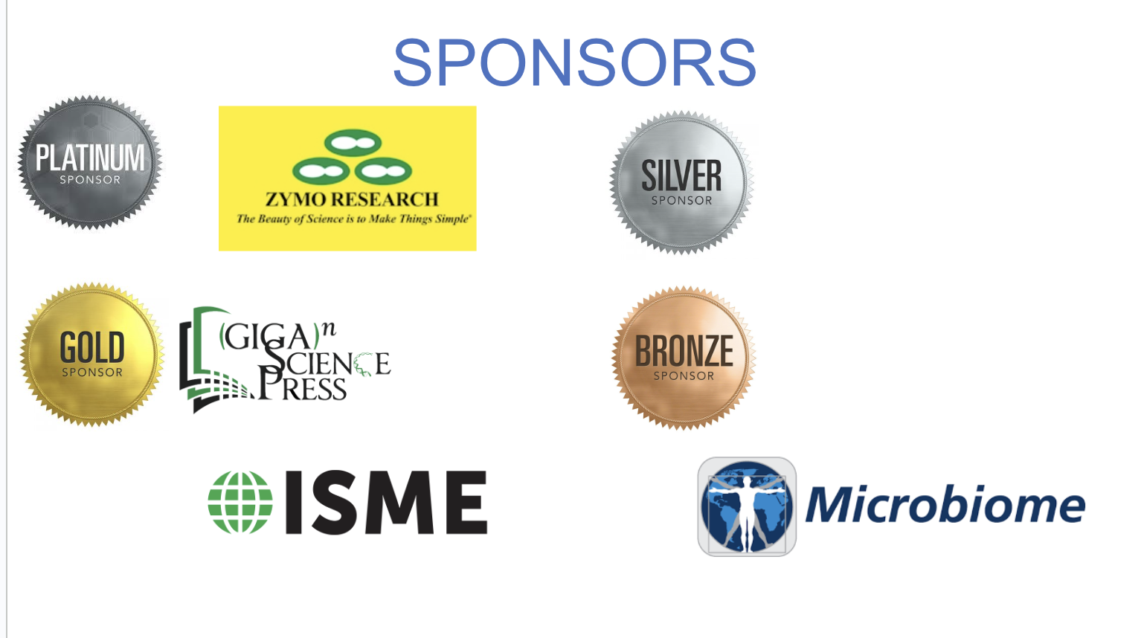

**Agenda Schedule**

**Monday, July 28 GSC board meeting**

* + 1:00-4:00 pm: Board Meeting

**Tuesday, July 29 GSC main meeting**

**Session 1: R20/30yrs of Genomes/GSC** Session Chair:

9:00-9:15  **Check In**

**Meeting Opening:** GSC President: Lynn Schriml, Local Hosts: Chris Hunter &

Rob Finn

9:15-10:00 Keynote:[**Ewan Birney**](https://www.ebi.ac.uk/people/person/ewan-birney/) (EMBL EBI):

**The opportunities and challenges of data and AI in the life sciences. A view from EMBL**

10:00-10:20 [**Owen White**](https://www.medschool.umaryland.edu/profiles/white-owen/) (University of Maryland School of Medicine):

**The role of the GSC during the sequencing revolution**

10:20-10:40 [**Nikos Kyrpides**](https://biosciences.lbl.gov/profiles/nikos-kyrpides/) (Joint Genome Institute, Department of Energy):

**The role of the GSC during the sequencing revolution**

10:40-11:00 Sponsor Talk

11:00-11:30 Coffee Break

11:30-11:50 [**Susanna-Assunta Sansone**](https://eng.ox.ac.uk/people/susanna-assunta-sansone/) (University of Oxford, UK): Data Reproducibility

11:50-12:10 [**Ilene Mizrachi**](https://www.linkedin.com/in/ilene-mizrachi-a7167717/) (National Center for Biotechnology Information, NIH): GSC

partnerships - INSDC

12:10-12:30 [**Guy Cochrane**](https://www.ebi.ac.uk/people/person/guy-cochrane/) (EMBI EBI, Global Biodata Coalition): GCBR, GBC

12:30-12:50 [**Saurabh Raghuvanshi**](https://www.dpmb.ac.in/index.php?page=SR) (University of Delhi South Campus): Genome India

12:50-14:00 **Lunch**

14:00-14:30 **Dawn Field Award**

[**James Fellows Yates**](https://www.eva.mpg.de/archaeogenetics/staff/james-fellows-yates/)(Max Planck Institute):

**The importance of community in the development of ancient DNA metadata standards**

14:30-14:50 [**Neil Davies**](https://www.moorea.berkeley.edu/people/Neil-Davies) (Gump South Pacific Research Station):

Biodiversity, TDWG, iSamples (Omic BON)

14:50-15:10 [**Dmitry Schigel**](https://adlignum.com/about/) (GBIF): Global Biodiversity Information Facility (GBIF)

15:10-15:30 [**Kerstin Howe**](https://www.sanger.ac.uk/person/howe-kerstin/) (Sanger Institute): Genomics standards for eukaryotic biodiversity sequencing

15:30-16:00 **Coffee Break**

16:00-17:00 Panel Discussion:

**With hindsight, what could have been done differently over the last 20/30yrs?**

18:00-23:00 Welcome Reception & BBQ

**Wednesday, July 30 GSC main meeting**

**Session 2: GSC standards** Session Chair:

8:45-9:00 Day 2 Welcome & Announcements

9:00-9:45 Keynote: [**Thulani Makhalanyane**](https://www.up.ac.za/research-matters/news/researchers/view-3089984-professor-thulani-makhalanyane) (University of Pretoria)

9:45-10:05 [**Chris Hunter**](https://www.linkedin.com/in/chr1shunter/) (GigaScience): **Update on GSC ongoing works over the last 12 months**

10:05-10:25 [**Sierra Moxon**](https://bioregistry.io/contributor/0000-0002-8719-7760)(Lawrence Berkeley National Laboratory): LinkML updates

10:25-10:40 [**Philipp Muench**](https://www.dzif.de/en/about-us/staff/dr-philipp-munch) ([Helmholtz Centre for Infection Research](https://www.helmholtz-hzi.de/en)):

**A platform facilitating MIxS-compliant metadata collection and data generation for microbial**

**omics projects**

10:40-11:15 **Coffee Break**

11:15-11;35 [**Peter Woollard**](https://www.embl.org/people/person/peter-woollard/) (EMBL-EBI): LinkML and ENA

11:35-11:55 [**Tanja Woyke**](https://biosciences.lbl.gov/profiles/tanja-woyke/) (Joint Genome Institute, Department of Energy):

**One Cell, Different Entities: Setting Standards for Microeukaryote Single-Cell Genomics**

11:55-12:15 [**Chris Kent**](https://research.birmingham.ac.uk/en/persons/chris-kent-2) (University of Birmingham): Data Standards for Multiplex Amplicon Sequencing

12:15-12:30 [**Emma Griffiths**](https://www.linkedin.com/in/emma-griffiths-a0a3383/?originalSubdomain=ca) (Simon Fraser University): Wastewater

12:30-13:30 **Lunch**

13:30-13:50 [**Miwa Takihashi**](https://www.linkedin.com/in/miwa-takahashi-b73817142/?originalSubdomain=au) (Australian Commonwealth Scientific and Industrial Research

Organisation):

**The FAIR eDNA (FAIRe) checklist: Towards consistent and reusable environmental DNA data**

13:50-14:10 [**David Bass**](https://www.cefas.co.uk/icoe/aquatic-animal-health/our-people/our-staff/david-bass/) (Centre for Environment, Fisheries and Aquaculture Science(CEFAS)): GBIF

14:10-14:30 [**Alexios Loukas**](https://www.linkedin.com/in/alexios-loukas-8b1a54b0/?originalSubdomain=gr)and [**Nefeli K. Venetsianou**](https://www.linkedin.com/in/nefeli-kleopatra-venetsianou-aa8261191/?originalSubdomain=gr) (Hellenic Centre for Marine

Research(HCMR)):

**CCMRI: A classification and curated database of climate change-related metagenomic studies.**

14:30-14:40 Sponsor Talk

14:45-15:30 **Coffee Break**

15:30-16:30 [**Chris Hunter**](https://www.linkedin.com/in/chr1shunter/)(GigaScience): Tutorial: SOPs & how we work

**Thursday, July 31 GSC main meeting**

**Session 4: Future of Genomics and Standards**. Session Chair:

8:45-9:00 Day 3 Welcome & Announcements

9:00-9:45 Keynote: [**Lara Urban**](https://sites.google.com/view/urban-lab/home?authuser=0) (Genomics and AI for One Health ):

**Squiggles to the rescue – Nanopore sequencing and Antimicrobial resistance**

9:45-10:05 [**Maaly Nassar**](https://www.linkedin.com/in/maaly-nassar-02391819/overlay/about-this-profile/) (Elsevier):

**AI-Driven Mutation Discovery: Linking Literature, Ontologies, and Patient Genomics for**

**Precision Gene Therapy.**

10:05-10:25 [**Kasthuri Venkateswaran**](https://www.linkedin.com/in/kasthuri-venkateswaran-82164b56/):

**Advancing shotgun metagenomics and digital PCR assays to meet future Planetary Protection**

**requirements.**

10:25-10:40 Sponsor Talk

10:40-11:15 **Coffee Break**

**Session 5: Inovations in Genomics and Standards**

11:15-11:35

11:35-11:55 [**Claire Rye**](https://www.linkedin.com/in/claire-rye-b390bb66/) (New Zealand eScience Infrastructure): GSC26

11:55-12:15 [**Leopold Parts**](https://www.sanger.ac.uk/person/parts-leopold/) (Sanger)

12:15-12:30 [**Fergal Martin**](https://www.ebi.ac.uk/people/person/fergal-martin/)(EMBL-EBI**): Deep learning and standards, genomics**

12:30-13:30 **Lunch**

13:30-13:45 GSC26 Handoff

13:45-14:15 **Panel Discussion**: Where are we going to be in another 20-30yrs?

**Friday, August 1st**

**GSC Workshop at EMBL-EBI**

**09:00 - 17:00 pm Advancing new MIxS standards towards MIxS v7.0: eDNA, ancient DNA**

**Workshop Descriptions:**

**CIG - MIxS standards:** The Compliance and Interoperability working group will meet to work on in-progress standards (e.g., eDNA, ancientDNA), MIxS checklists and extensions.